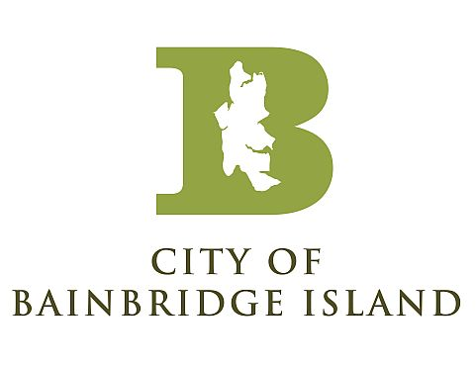
Emergency Management Advisory Committee (EMAC)

December 2, 2020 2:00 PM – 3:30 PM

zoom meeting

MEETING NOTES

Attendees(14): Peter Bang-Knudsen (BISD), Loren Bast (BP), Sanjay Bhatt (Kitsap Transit), Chief Joe Clark (BIPD), Lit Dudley (WSDOT), Jessica Guidry (KPHD), David Henry (BIMPRD), Scott James (BP), Lis Klute (KCDEM), Chuck Krumheuer (COBI), Anne LeSage (COBI), Cherrie May (Suquamish Tribe), Ellen Schroer (COBI), Jane Stone (BI Land Trust)

- Welcome/Introductions
  - Meeting began at 2:02 PM

- Review Notes/Action Items from September 2019 Meeting
  - Group reviewed the notes from the September meeting
  - No changes

- Review Updated EMAC Charter
  - Group reviewed the Charter
  - Welcome to new members: Jane Stone – BI Land Trust, Chief Clark – BI Police Department, Sanjay Bhatt - Kitsap Transit, Cherrie May – Suquamish Tribe

- COVID-19 Discussion
  - Group discussed general COVID response activities
  - COBI – EOC activated March – August, focused on communication and resource requests. Now focused on operating testing site. Started November 4th, open M/W/F 1-5. Tested 357 individuals so far.
  - BP – volunteer support for testing site. Assisted BI Senior Living with implementing their own testing program.
  - Suquamish Tribe – EOC activated since March. Operating testing site to support community and employees. Testing 1100 individuals so far. Working on vaccine planning for the tribe. Daycare open to essential workers only. Shifting to winter weather preparedness efforts.
  - Parks District – had to shut down remaining programs with latest guidance.
  - Health District – case rate has quadrupled over the last month. New cases coming from smaller gatherings and workplace exposures. Healthcare capacity in the County is ok for now. Looking to shift testing operations from outdoor locations to parking garages in the County. Focusing on vaccine planning. Hope to establish a community advisory group. Washington is expecting first shipment of the vaccine in mid-December
  - KCDEM – EOC activated. Virtual since March 13th. CARES act funding, spent by November 30th. Purchased numerous assets for the County – 2 uv sanitation unit trailers, PPE supply trailer, 3 stall portable bathroom, 2 tow vehicles, mobile command center, and purchased a new campus with warehouse capability.
  - Kitsap Transit – work focused on protecting employees, customer safety, and community messaging. Purchased PPE for bus and ferry operations, installed hand sanitizer dispensers, UV light air scrubbers on buses and ferries, developed six new commercials to air in 2021.

- Other Partner Updates

  - Bainbridge Prepares
    - Focusing on volunteer recruitment
    - Some teams getting back to other disaster planning focusing on earthquakes and wildfires
    - Continuing work on disaster hubs
  - BI Land Trust
    - Working on wildfire risk, mitigation activities for forest land.
    - Engaging a forester for technical review of land
  - Fire Department
    - BIFD continues to operate from a contingency position with respect to COVID.
    - BIFD is transferring ownership of an unused trailer for use by Bainbridge Prepares for the Hubs.
    - BIFD is working closely with City Planning Staff on new code language for wildfire mitigation to bring the City’s Tree and Vegetation regulations into conformance with the new BI Climate Action Plan (which places emphasis on Firewise). This is a BIG deal for hazard mitigation and one that BIFD has been working on for over 10 years!
  - COBI Public Works
    - Focusing on winter weather preparedness and wind/snow event staff scheduling
    - Changed shifts during COVID to increase social distancing
  - Kitsap County DEM
  - Kitsap Public Health District
  - Kitsap Transit
  - Northwest Healthcare Response Network
  - Parks District
  - Police Department
    - Seeing COVID fatigue among staff with increase in protests, keeping the department busy
    - May have to support security needs for vaccine distribution
  - Puget Sound Energy
  - Rotary Club of Bainbridge Island
  - School District
    - Looking to get kids back in school in late January/early February
    - Finding that students are not engaging in the same way, lower grades, increase signs of mental distress
    - Working on snow & ice plan for winter
  - Suquamish Tribe
  - WSDOT/WSF
    - Taking COVID precautions for crews
    - Working on winter weather preparedness

- 2020 Workplan Status Report
  - Primary shift in workplan from EOC training to EOC activation, in-person to remote training, and stockpiling supplies to acquisition and distribution of supplies

- 2021 Workplan
  - Workplan for next year continues to focus on remote engagement and training for volunteers and community

- 2020-2022 Strategic Plan
  - Still working to achieve the goals set forth in the strategic plan

- Roundtable

- Meeting adjourned at 3:17 PM

Next Meeting: March 2021, TBD

